Name: **Ace Tadalan**

Student Number: **2410996**

Course: **PLD 007**

Program & Section: **CpE11S1**

**Exercise 1**

**1. What is a computer?**

* 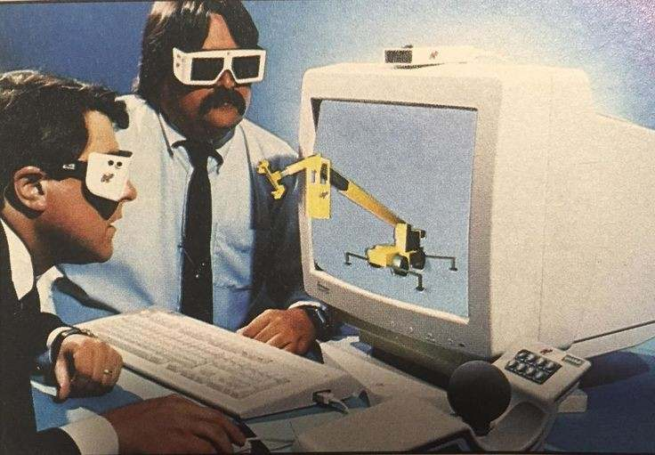A computer is an electronic device that can process data based on a program. Computers before only designed and used for computing or calculation. Today, computers can now perform a wide range of tasks, such as playing games, researching, and can run a complex operation. Computers are valuable in today’s generation because of its ability to process and store data, problem solving, make communication easy, access to a wide source of learning and entertainment through internet. Having computer can improve efficiency and reduce most human error

**2. What are the essential parts of a computer?**

* 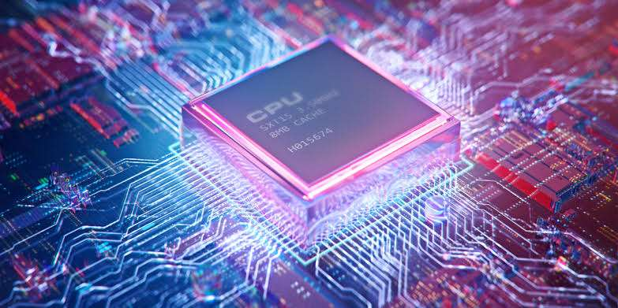**Central Processing Unit (CPU):** CPU is the source of instruction from the program that runs through a cycle, from getting the from the memory then decoding the instructions and executing the instruction. CPU consists of ALU (Arithmetic Logic Unit) and CU (Control Unit). ALU calculates and perform and run logical operations while CU directs the operations and manage the flow of data.

* 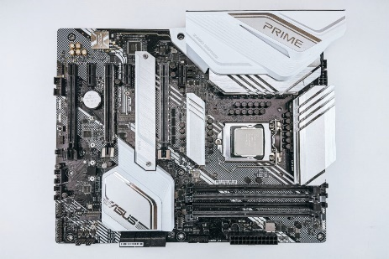**Motherboard:** Motherboard is also called as backplane board, system/logic board or a main circuit board. It allows various parts of computer to communicate with each other, it is also responsible for distributing power supply to make sure the computer is receiving electricity and to function properly.
* 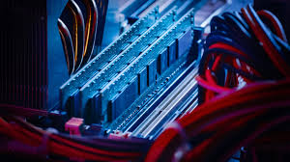**Random Access Memory (RAM):** RAM provides the CPU a space to read, write and run data quickly. It allows the computer to perform well by multitasking, process efficiency, and handle large files or complex tasks.
* 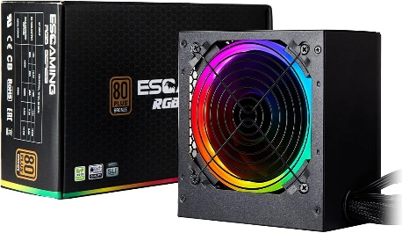**Power Supply Unit (PSU):** Ensures the correct voltages are delivered to some parts of the computer, such as the motherboard, CPU, GPU, and storage devices, to maintain the stability and reliability of operations.

**3. Who are the notable inventors of hardware & software**

**SOFTWARE**

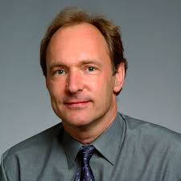

1. **Tim Berners-Lee –** He was born on June 8, 1955 at London, England. He was knighted by Queen Elizabeth II of United Kingdom because of his “services to the global development of the internet” and it is his invention the well known “World Wide Web”. Berners-lee with his colleague Robert Cailliau created the first web browser that is called the WorldWideWeb the and was released publicly on 1991 the first website was put online.
2. 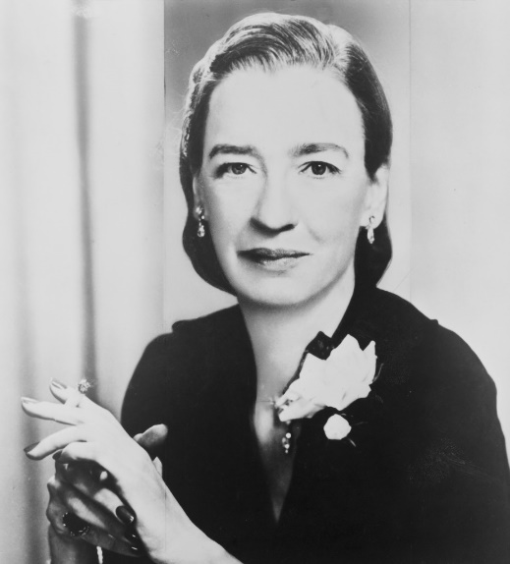**Grace Hopper –** Born on December 9, 1906 at New York, U.S. an American mathematician and an expert in developing computer technology. She was known for her contribution to the development of the Common Business Oriented Language (COBOL) high level programming language designed for business, because of her ambition for making computing accessible for business, had an important impact on the field of computer science and business data processing. She is also credited to the developing of the first compiler the A-O or the Alpha and Omega UNIVAC I. This is the necessary for building foundation for the development of modern programming languages and software development, Because of her is stablished the concept of “Software” the separate from what “Hardware” is.
3. 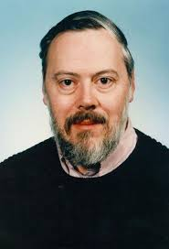**Dennis Ritchie –** He have a bachelor’s degree in physics (1963) and a doctorate in mathematics (1968) from Harvard University. In 1970 he developed the C programming language and it is designed as the evolution of the B programming because of it, it cause a major step for the development of software. This became the structured foundation of the modern programming language such as C#, C++, Java and Phyton.
4. 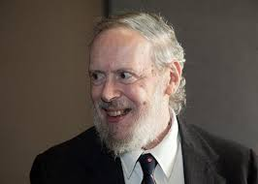**Ken Thompson –** In 1960 he developed the B programming language, it was design to be simple and efficient. He co-developed the Unix Operating System by the use of C programming language. This innovations of him did shape the operating system, programming and software development.
5. 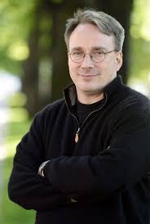**Linus Torvalds –** When he is still a computer science student at the University of Helsinki, he began developing the Linux kernel. The initial release of Linux kernel ver.0.01, was available to a small group of who are interested and other developers. This is the foundation of other operating system like Ubuntu, Fedora, and Debian. Linux became the most used open operating system across to various devices and other existing servers.
6. 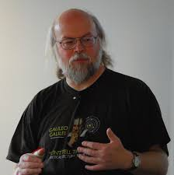**James Gosling –** “The Father of Java Programming Language”, in May 1955 Gosiling founded and lead designed the Java programming language. Java become the most important to the development of software because of its security, ease to use, and its design to meet the needs of the programmers. His work also contributes to the development of Java Virtual Machine (JVM) that can run the Java programs to any device and converts Java code to instructions that devices can understand, it provides portability and functions like a memory management and has security.

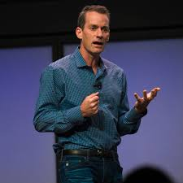

1. **Jeff Dean –** A researcher that help to developed the Google, a co-developer of MapReduce a programming model that can assess large amount of datasets from the computers. Also designed Bigtable a system for handling structured data and distributed. Dean’s expertise help Google, also Spanner a system that managing global database and ensure data consistency and reliability.

**HARWARE**



1. **Jaron Lanier –** One of the experts who develop Virtual Reality (VR) and the DataGlove a device that allows the users to interact with the environment virtually using hand movements. He founded VPL Research, one of the first companies that focuses on VR. He created VR hardware that influence modern VR system this contributes in shaping the experience and interaction with virtual world that we enjoy today.
2. 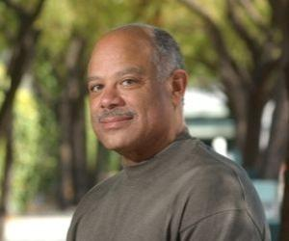**Mark Dean –** A computer scientist and an engineer that help many companies to develop technologies for IBM, including the colored PC monitor and the first gigahertz chip. As he develop the first gigahertz chip it improves the computer speed. Also Dean invented the Industry Standard Architecture (ISA) a hardware that is added to PC which allows the PC to add expansion cars such as the sound cards and network cards.



1. **Hedy Lamarr –** Who is known by being Austrian-American actress and co-inventor of Frequency Hoping this allows technology such as radio to change radio frequency quickly to less any interference and interception to other users this improves security of military communication during the WW2. Because of this it improves wireless communication through technologies including GPS, Bluetooth, and Wi-Fi.

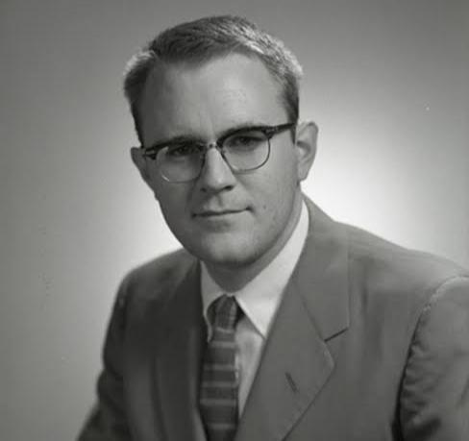

1. **Gordon Bell –** An engineer and a contributor to the development of computer hardware. Part of the creation of the Digital, Equipment Corporation (DEC) company that release the PDP-8 the first minicomputer were sold to the public. This minicomputer had basic instruction set that can handle small scale application which is good for educational purposes, while the PDP-11 featured advance specification and orthogonal instruction set which make is easier for the programs to run and can handle more versatile various applications. This influence and help the computers that is widely used to improve.
2. 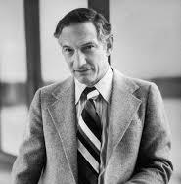**Robert Noyce –** Notable for his invention the Integrated Circuit (IC), this is a combination of transistor, resistors, and capacitors in one chip. And as he cofounded the Intel he improve and popularize the microprocessor, a type of IC that works as the CPU of a computer. This cause a huge impact on the development of the modern electronics and computing hardware.

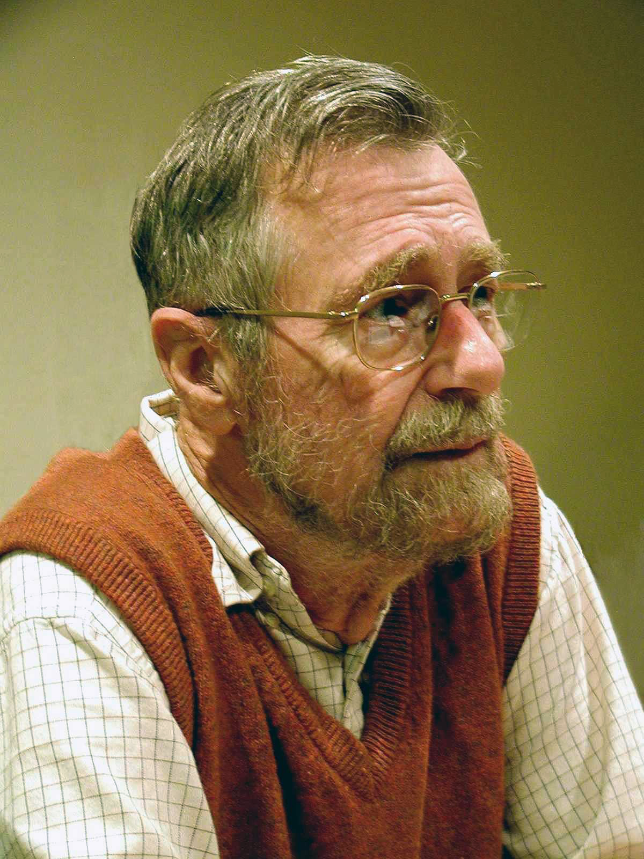

1. **Edsger W. Dijkstra –** A Dutch computer scientist that improves the paradigm of programming for writing computer programs. His work impacted hardware systems by his contributions to algorithms and concurrency. His development of semaphores improved the process of synchronization, and enhancing the efficiency of multitasking in hardware systems.

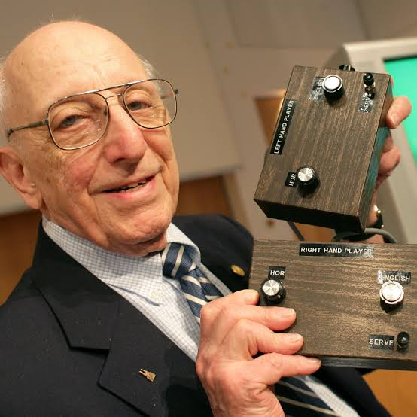

1. **Ralph H. Baer –** “Father of Video Games” he is known for his invention the Magnavox Odyssey the fist commercially available home video game console. It came with simple games like Pong and Table tennis. His inventions were important in building the video game market and shaping the future of gaming technology.

**4. Cite your reference/s**

1. **Computer**

* GCF Global. (2019). Computer Basics: What is a Computer? GCFGlobal.org. <https://edu.gcfglobal.org/en/computerbasics/what-is-a-computer/1/>

1. **Important Parts of Compute**

* Indeed Editorial Team. (2023, August 1). 11 Basic Components of Computer Hardware: Tips for Technicians. Indeed Career Guide. <https://www.indeed.com/career-advice/career-development/what-are-basic-components-of-computer-hardware>

1. **Notable Inventors**
2. **Software**

**•** Dennis, M. A. (2024, July 5). *Tim Berners-Lee | Biography, Education, Internet, Contributions, & Facts*. Encyclopedia Britannica. <https://www.britannica.com/biography/Tim-Berners-Lee>

**•** Grace Hopper. (2021, May 10). *Biography*. <https://www.biography.com/scientist/grace-hopper>

**•** Hosch, W. L. (2024, July 5). *Dennis M. Ritchie | Biography & Facts*. Encyclopedia Britannica. <https://www.britannica.com/biography/Dennis-M-Ritchie>

**•** Computer History Museum. (2021, February 12). *Ken Thompson - CHM*. CHM. <https://computerhistory.org/profile/ken-thompson/>

**•** The Editors of Encyclopaedia Britannica. (2024, August 14). *Linus Torvalds | Biography, Linux, & Facts*. Encyclopedia Britannica. <https://www.britannica.com/biography/Linus-Torvalds>

**•** Mishra, N. (2024, April 7). *James Gosling Biography - Father of Java Programming Language - The Java Programmer*. The Java Programmer. <https://www.thejavaprogrammer.com/james-gosling-biography/>

**•** *Jeffrey Dean*. (n.d.). <https://research.google/people/jeff/?&>

1. **Hardware**

**•** Lanier, J. (2024, February 2). Where will virtual reality take us? *The New Yorker*. <https://www.newyorker.com/tech/annals-of-technology/where-will-virtual-reality-take-us>

• Biography.com Editors. (2024, February 21). Mark Dean. *Biography*. <https://www.biography.com/inventors/mark-dean>

• Hedy Lamarr. (2021, April 19). *Biography*. <https://www.biography.com/actors/hedy-lamarr>

• Hhackford. (2024, May 28). *In memoriam: Gordon Bell (1934–2024)*. CHM. <https://computerhistory.org/blog/in-memoriam-gordon-bell-1934-2024/>

• *Robert Noyce, statesman of Silicon Valley*. Intel. (n.d.). <https://www.intel.com/content/www/us/en/history/museum-robert-noyce.html>

• The Editors of Encyclopaedia Britannica. (2024a, August 2). *Edsger Dijkstra | Biography, Algorithm, & Facts*. Encyclopedia Britannica. <https://www.britannica.com/biography/Edsger-Dijkstra>

• Martin, D. (2014, December 8). *Ralph H. Baer, inventor of first system for home video games, is dead at 92*. The New York Times. <https://www.nytimes.com/2014/12/08/business/ralph-h-baer-dies-inventor-of-odyssey-first-system-for-home-video-games.html>